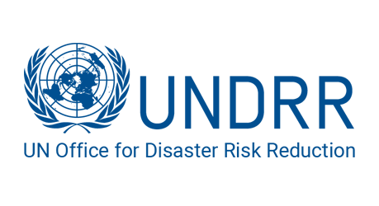 

**Committee:** United Nations Office for Disaster Risk Reduction

**Country:** The Commonwealth of Australia

**Agenda:** Enhancing inclusive early warning early action in disaster prone regions to achieve zero climate disasters.

For the sake of eradicating the devastating impacts of climate change, achieving #ZeroClimateDisasters is an ambitious but necessary goal. UNDRR’s #ZeroClimateDisasters campaign aims to double down on vulnerability, poverty and inequality to achieve the [UN SDGs](https://sdgs.un.org/goals), scale up effective comprehensive risk management, and ensuring early warning and action for all by 2027. In the core of this objective lies the enhancement of inclusive early warning and early action (EWEA) systems. The global economic losses from climate-related disasters were estimated at $210 billion in 2020, a significant increase from the previous decade's average of $140 billion per year. As a nation frequently affected by climate-related disasters such as bushfires, floods, and cyclones, Australia highlights the critical need for effective early warning systems (EWS) and early action (EA) strategies. Australia is a founding member of the "Early Warnings for All" initiative, which aims to ensure everyone on Earth is protected by effective early warning systems by 2027. Australia promotes the development of inclusive Early Warning Early Action (EWEA) systems that reach all populations, including marginalized groups.